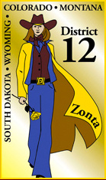
New Member Orientation Manual
Revision Date: 1/15/2014

Table of Contents
Overview 3
About this Manual 3
What Is Zonta International? 3
Zonta at a Glance 3
Zonta Vision 4
Objectives 4
Zonta History and Symbols 5
The Zonta Emblem 5
The Zonta Rose 6
Membership 6
Membership Responsibilities 6
Zonta’s Appeal – Why Join? 7
Service and Advocacy 7
Networking and Fellowship 7
Diversity 7
Personal Development 7
Advancement of Women 7
International Interaction and Travel 7
Zonta Organizational Structure 8
Headquarters 8
International Board 8
District Board 8
Club Boards 8
International Committee Chairs 8
District Committee Chair 8
Club Committee Chair 8
Zonta International Foundation 8
Zonta International Strategies to End Violence Against Women (ZISVAW) 10
Zonta District 12 11
District 12 Leadership – 2012-2014 11
District 12 Clubs 12
Area 1: South Dakota / Montana 12
Area 2: Wyoming / Northern Colorado 12
Area 3: Denver Metro 12
Area 4: Southern Colorado 13
Conventions, Conferences, Seminars and Meetings 13
Zonta Club of ____________ 14
Zonta Calendar of Events 15
Upcoming Events in 2014 15
Zonta Additional Resources 15
Appendices 16

Overview
Welcome to Zonta. Congratulations on your decision to become part of a worldwide organization of professionals that work together through service and advocacy to advance the status of women worldwide. You are now a critical member of a global team.

There are numerous issues that affect women and girls locally and abroad and our work as Zontians makes a difference in the lives of women and girls everywhere. As one person my ability to be a catalyst for needed changes may be limited, but when I join together with likeminded individuals, I become a stone cast into vast waters that creates a ripple effect the world over. I am doing my part to bring attention to issues facing women and girls, and my part to end gender based violence, poverty, lack of access to education, gender based wage discrepancies, human trafficking, lack of access to needed health services, lack of women in leadership roles, child brides, gender mutilation, and the lack of knowledge about these pervasive problems.

About this Manual
This manual is intended to be a living document that is updated as needed. Individual clubs can edit the manual and add their own pertinent information as they deem necessary. This manual should be an accompaniment to other Zonta Resources, including the Zonta District 12 web site: http://zontadistrict12.org/

What Is Zonta International?
Founded in 1919 by Marian de Forest, in Buffalo, New York, Zonta International is a global organization of executives and professionals working together to advance the status of women worldwide through service and advocacy. With more than 30,000 members belonging to more than 1200 Zonta Clubs in over 65 countries and geographic areas. Zontians all over the world volunteer their time, talents and support to local and international service projects, as well as scholarship programs aimed at fulfilling Zonta’s mission and objectives.

Zonta at a Glance
- Founded 1919 in Buffalo, New York
- Today there are over 30,000 members in more than 1200 clubs in more than 65 countries
- The Zonta International Board:
  - Directs the affairs of Zonta International
  - Consists of four elected officers, who constitutes the executive committee, and seven elected directors
  - Elected at the biennial international conventions
  - Four elected officers are:
    - President
    - President-Elect
    - Vice president
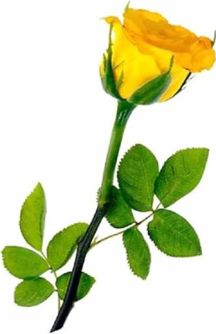
    - Treasurer/Secretary
- Districts:
  - For administrative purposes, Zonta International divides the world into districts
  - Each district is supervised by an elected governor and elected district board
  - The elected officers of the district are:
    - Governor
    - Lieutenant Governor
    - Area Directors
    - Treasurer
    - Secretary (appointed by the governor and has no vote)
- Areas:
  - Districts are divided into areas
- Clubs:
  - The basic organizational unit of Zonta International
- Operations are concerned with how we operate and function
- Service is what we achieve for others

Zonta Vision
Zonta International envisions a world in which women’s rights are recognized as human rights and every woman is able to achieve her full potential. In such a world, every woman is literate and has access to education, health care, legal and economic resources on an equal basis with men. In such a world, no woman lives in fear of violence.

Objectives
- To improve the legal, political, economic, educational, health and professional status of women at the global and local level through service and advocacy.
- To work for the advancement of understanding, goodwill and peace through a world of fellowship of executives in business and the professions.
- To promote justice and universal respect for human rights and fundamental freedoms.
- To be united internationally to foster high ethical standards, to implement service programs, and to provide mutual support and fellowship for members who serve their communities, their nations, and the world.

Zonta International, its districts and its clubs are nonsectarian and nonpartisan.

Zonta History and Symbols

The Zonta Emblem
The origin of the word "Zonta" is from the language of the Sioux Indian, and it was adopted as the Zonta International name in 1919. The Zonta emblem is just as familiar to members as is the word "Zonta," and there is an equally interesting story about its evolution. The emblem is not simply a decorative design. It is an adaptation and composite of several Sioux Indian symbols which when superimposed take on a special significance for Zontians.
 |  | What appears to be the letter "Z" is actually the Sioux symbol for "ray of light," "sunshine" or "flash of radiance"--and so by extension, "inspiration."
 |  | This Sioux symbol means "to band together for a purpose" or "to stand together"--in a word, "loyalty". With loyalty, individual members band together into clubs, clubs into districts, and districts into Zonta International. So loyalty surrounds the radiance and the inspiration as a familiar pattern begins to emerge.
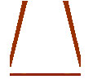 |  | This is the Sioux way of saying "to carry together". Carrying together is a most important ingredient for the accomplishment of Zonta's purpose: to work for the advancement of understanding, good will and peace through a world fellowship of business executives and professionals. This symbol has been conventionalized to lend itself to the total pattern and slips over the inspiration and the loyalty to draw members closer together.
 |  | This is the Sioux symbol for "shelter". Zonta's many service projects are in a real and broad sense shelter for someone or something. And service is synonymous with Zonta. This symbol therefore lends itself importantly in significance and design, embodying Zonta's aims and aspirations.
 |  | The symbolism of the square is not exclusively Sioux, nor indeed is it exclusively Native American. It perhaps dates back even further than all of these other symbols in its representation of "honesty" and "trust"--strong and vital qualities with which to bind together the parts of the whole.
 |  | This symbol--composed of many symbols--became Zonta's emblem signifying a radiant group of successful business executives and professionals who are loyal to the same inspired goals of service and world understanding with none but the most honest and trustworthy motives.

During the 1996-1998 Biennium the Zonta International Board voted to have the words "Zonta International" incorporated into the emblem to standardize its appearance and enhance recognition of Zonta International throughout the world.

The Zonta Rose
The beauty of a single yellow rose has been a favorite Zonta symbol for decades. The yellow rose has adorned many Zonta items from stationery to clothing, and has been used in many charter and anniversary celebrations.
The Zonta Rose is much more than a lovely flower. Since 1999, it has served as the symbol of Zonta Rose Day, which falls on 8 March and coincides with International Women’s Day. On this special Day, Zontians worldwide are encouraged to publicly distribute yellow roses, or items bearing the image of yellow roses, accompanied by information about Zonta International and issues relating to improving the lives of women.

Membership
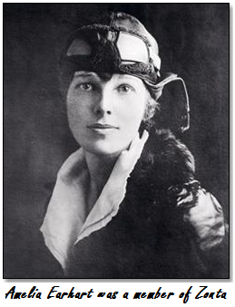
Zonta is a classified organization which draws its members from a variety of businesses and professions in the community, giving Zonta members the opportunity to meet executives and professionals in a variety of occupations, whose work is very different from their own. Membership is by invitation only.

To ensure that Club members are a diverse group of executives and professionals, the Zonta International By-Laws require Clubs to meet the following criteria:
- The occupation of the prospective members must have experience in a decision-making capacity or in the professions.
- The quality of the business or profession must be reputable and recognized.
- The prospective member must be of good character and have a good business/professional reputation.
- Potential members must be willing to support and implement the Objects of Zonta International.
- Each Club must have members actively engaged in at least one-fourth as many classifications as the Club has members, i.e.20 members –minimum 5 classifications; 40 members-minimum 10 classifications.

Membership Responsibilities
- Attend club and relevant committee meetings
- Pay all dues, fees and assessments promptly
- Be familiar with club bylaws and parliamentary procedures
- Participate actively in meetings and deliberations and accept majority decisions
- Accept leadership roles and give time, talent and enthusiasm to the organization
- Identify and suggest prospective new members
- Attend area meetings/workshops, district conferences and international conventions, if possible
- Support the programs of the Zonta International Foundation

Zonta’s Appeal – Why Join?
The rewards of membership in Zonta International are far reaching:
- Make a difference in the lives of women and girls everywhere
- Participate in and support quality service, advocacy and scholarship programs
- Meet a diverse range of executives and professionals through member networking.
- Build leadership and mentoring skills
- Enjoy fellowship and fun through international understanding

Service and Advocacy
Zonta members serve and advocate for women and participate in activities that make a difference locally and internationally.

Networking and Fellowship
Zonta provides the vehicle for members who share common values to work together to meet common goals. You will meet a diverse group of interesting and stimulating women, locally, nationally, and internationally. You are welcome at Clubs worldwide.

Diversity
Zonta’s classification system ensures a broad membership drawn from many businesses and professions, and thus provides opportunities for interaction with others outside one’s own particular area of expertise.

Personal Development
Zonta provides members interested in developing leadership potential with opportunities for growth at a variety of levels; in the local Club, at the District level, or the International level. You will learn new skills and gain self-confidence in a caring and supportive environment.

Advancement of Women
Zonta Clubs work on both the local and international level for the advancement of women. Zontians serve as role models within their own community.

International Interaction and Travel
Zonta provides members with a rare opportunity for international participation through its links with several United Nations agencies, through annual workshops and conferences and through its biennial international convention.
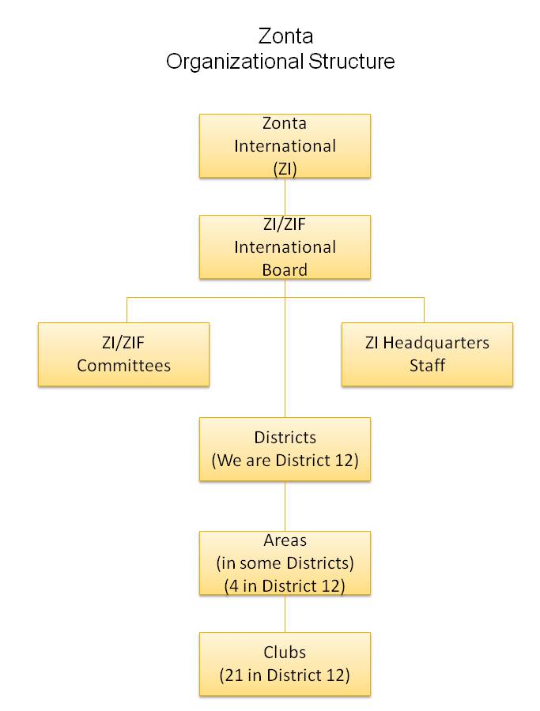
Zonta Organizational Structure

Headquarters
1211 West 22nd Street, Suite 900
Oak Brook, IL 60523
Phone: 630-928-1400
Fax: 630-928-1559
Email: zontaintl@zonta.org

International Board
Elected at International Conventions (all Clubs vote). International President, President Elect, Vice President and Treasurer; plus seven International Directors.

District Board
Elected at District Conference by all Clubs in that District. District Governor, Lt Governor, Treasurer and Area Directors, and Vice Area Directors (non-voting). The Secretary and Parliamentarian are non-voting, appointed by District Governor.

Club Boards
Elected by Club members. President, Vice President, Recording and Corresponding Secretaries, Treasurer, and 4-6 Directors (depending on the size of the Club).

International Committee Chairs
ZI has various Committees to carry out the work of the organization. These Committees have Chairs appointed by the International President. They set goals and give guidelines for the biennium and communicate with districts and clubs through various mediums.

District Committee Chair
Districts also have Committees to carry out the work of the District. These Committees have Chairs appointed by the District Governor. They give guidance and assistance to Club Committee Chairs.

Club Committee Chair
Clubs must have a Membership Chair, a Service Chair and an Advocacy Chair. Other Committee Chairs may be appointed as deemed appropriate by the Club. Club Chairs are defined by local club rules and they coordinate committee activities and delegate tasks involving all Club members.

Zonta International Foundation
The Zonta International Foundation raises and oversees funds used to support and promote the following global service programs of Zonta International:
- The Rose Fund enables leadership to expand programs and projects as needed and respond to immediate needs that may arise. Supports the general operations and administration of Zonta service programs and other activities.
- The International Service Fund supports different projects each biennium that improve the quality of life for women through developing women’s leadership and economic skills. The ZISVAW Fund (Zonta International Strategies to Eradicate Violence Against Women and Children) focuses on prevention, awareness and education to eliminate violence against women and children.
- The Endowment Fund generates annual revenue from the earnings. A gift to the Endowment Fund is a permanent gift, a lasting legacy to Zonta’s future service.

In addition, Zonta International maintains funds for scholarships and awards which advance educational and leadership opportunities for women:

The Amelia Earhart Fellowship Awards began in 1938. Amelia Earhart was a Zontian from 1928-1937. She was a member when she disappeared in 1937 while attempting to circle the world by air. These awards, valued at US $10,000 each, were established in her memory and are given to provide financial assistance to women pursuing graduate degrees in aerospace science and engineering. Since 1938, 1,333 Fellowships have been given to women representing 65 countries. (Total Dollars Awarded: US $7.5 million)

The Jane M. Klausman Women in Business Scholarships were established in 1998 through the legacy of Jane M. Klausman, Zonta International Parliamentarian and member of the Zonta Club of Syracuse, New York. These scholarships provide financial assistance to women pursuing undergraduate degrees in business management. Since its inception, 275 scholarships have been awarded to women representing 42 countries. (Total Dollars Awarded: US $552,800).

The Young Women In Public Affairs Awards were established in 1990 with start-up funding from investment income from the Endowment fund; now funded entirely from annual contributions. The purpose of these awards is to foster women’s involvement in the upper levels of government and society by honoring young women leaders and volunteers. Since its inception, 601 awards have been given to women representing 50 countries. (Total Dollars Awarded: US $430,750)

Every contribution is important as it assists the Zonta International Foundation in helping women and girls worldwide. Please help make Zonta’s vision of women’s equality a reality by making a contribution this year and each year.

Money contributed to the Zonta International Foundation is professionally managed and carefully allocated. For further information on any of the above Funds, please see the information on the Zonta International website at www.zonta.org. The Zonta International Foundation is a 501(c)(3) charitable organization registered in the United States; contributions are tax deductible to the extent allowed by U.S. law. Tax deductibility outside the U.S. is dependent on local tax regulations.

International Service Projects
As Zonta is committed to international service, it is recommended that clubs contribute 1/3 of its fundraised dollars to support the current projects, which help implement our Mission Statement to elevate the status of women. If potential members are not comfortable with the concept of funds going out of their country, then Zonta is not the organization for them to join.

Helping women in developing countries has been a passion of Zontians since the organization was founded in 1919. Today, Zonta’s International Service Program continues to help women in developing countries improve their legal, political, economic, educational, and health status. Through funding from the Zonta International Foundation, the Program has provided training, education, health, sanitation, agricultural and micro-credit assistance to women, primarily through projects implemented by the agencies of the United Nations and other recognized non-governmental organizations (NGO’s).

Since 1923, Zonta has provided more than US $30 million to projects benefiting more than 2 million women in 37 countries. Zontians select new International Service Projects and initiatives during each biennium at the Zonta International Convention.

The 2012-2014 biennium International Service Projects include:
- Prevention of Mother-to-Child Transmission of HIV and Gender-Based Violence in Rwanda with UNICEF will continue to focus on the prevention of mother-to-child transmission of HIV by providing the full range of family package services at 20 UNICEF supported PMTCT sites throughout Rwanda. In addition, the project will seek to expand holistic care and services at support centers for survivors of domestic and gender-based violence to ensure access to proper medical, legal, psychosocial and police support. ($1,000,000)
- Towards Elimination of Obstetric Fistula and the Reduction of Maternal and Newborn Mortality and Morbidity in Liberia with UNFPA will continue to provide fistula treatment though the proper equipment of health care facilities and the training and capacity strengthening of health care providers to treat fistula. The project will also continue to focus on the reintegration of survivors while raising awareness and conducting outreach among communities and health care providers about the definition, causes and treatment of obstetric fistula. ($1,000,000)

Zonta International Strategies to End Violence Against Women (ZISVAW)
Globally, gender-based violence is the most pervasive and least recognized human rights violation. Rooted in inequality, it affects women of every race, class, culture, ethnicity, age and country. Zonta International strives to promote and protect the human rights of all women and girls and reduce the incidence of violence through the Zonta International Strategies to End Violence Against Women (ZISVAW) Program by:
- Supporting prevention and advocacy strategies locally and internationally.
- Awarding grants to United Nations agencies or recognized NGOs for projects that seek to change personal and/or political knowledge, attitudes and behavior contributing to gender-based violence.
- Increasing awareness and actions related to preventing violence against women by encouraging Zonta club involvement in local and national advocacy initiatives and service projects.

Since the program's inception in 1999, more than US $2 million has been provided to support 40 projects in more than 23 countries.
During the 2012-2014 Biennium, three projects are being supported by the ZISVAW Fund:
- Mass Communication with a Purpose: Global Partnership on Edutainment for Social Change
- Safe Cities for Women in Honduras
- Empowering Women in Rural Samoa to Combat Violence

Zonta District 12
Zonta District 12's purpose is to build, develop, and maintain strong clubs through support, leadership and communications in order to further the mission of Zonta International.

District 12 Leadership – 2012-2014
Sheila Davis, Denver • Governor
Marcy O’Toole, Denver II • Lt. Governor and Membership Chair
Bridget Masters, Fort Collins • Treasurer and Finance Chair
Denise Luckhurst, Pierre/Fort Pierre • Secretary
Mary Benoit, Denver • Centurion
Renee Coppock, Billings • Area 1 Director
Teresa Forbes, Sturgis • Vice Area 1 Director
Deedee Boysen, Laramie • Area 2 Director
Michelle Ammerman, Cheyenne • Vice Area 2 Director
Debbie Squires, Boulder Cty • Area 3 Director
Ann Hodgson, Foothills • Vice Area 3 Director
Janet Bergin, Royal Gorge • Area 4 Director
Linda Hawkins, Prowers Cty • Vice Area 4 Director
Barbara Pellegren • Denver Archivist and Historian
Deb Beatty, Lakewood/Golden • Bylaws and Resolutions Chair
Tommie Atanasoff • Foothills Foundation Ambassador
Kari Winter • Lakewood/Golden Internal Communications Chair
Jodi Gostas • Cheyenne Outreach Editor
Susie Nulty • Pikes Peak Webmaster
Andrea Hovey Black Hills and Angela Ver Ploeg Laramie • External Communications/PR Co-Chairs
Jane Page, Pierre/Fort Pierre • Advocacy/UN Chair
Nikki Headlee, Denver • Nominating Committee Chair
Sue Konstant, Spearfish • Nominating Committee Member
Mary Walker, Cheyenne • Nominating Committee Member
Ann Hefenieder, Billings • Parlimentarian
Ann Hodgson, Foothills • Service and Scholarships Chair
Debbie Squires, Boulder Cty • Amelia Earhart Scholarship Coordinator
Evie Ashmore, Denver • Jane M. Klausman Scholarship Coordinator
Laura Stamp, Pikes Peak • YWPA Coordinator
Deedee Boysen, Laramie • Z and Golden Z Coordinator

District 12 Clubs
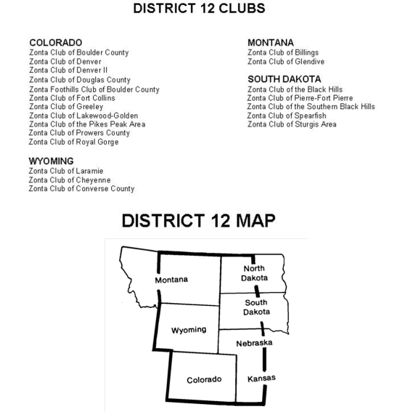
Area 1: South Dakota / Montana
zontadistrict12.org/area1/area1.html
South Dakota:
- Black Hills: zontacluboftheblackhills.org/
- Pierre-Ft. Pierre: zontadistrict12.org/pierre/
- Sturgis: zontadistrict12.org/sturgis/
- Spearfish: zontadistrict12.org/spearfish/
- Southern Black Hills: zontadistrict12.org/soblackhills/
Montana:
- Billings: www.billingszonta.org/
- Glendive: zontadistrict12.org/glendive/

Area 2: Wyoming / Northern Colorado
Wyoming:
- Cheyenne: www.zontaofcheyenne.org/
- Converse County: zontadistrict12.org/converse/
- Laramie: zontadistrict12.org/laramie/
Colorado:
- Fort Collins: zontadistrict12.org/FtCZonta/ftchome.htm
- Greeley: zontadistrict12.org/greeley

Area 3: Denver Metro
zontadistrict12.org/area3.html
- Boulder: zontadistrict12.org/boulder/
- Denver: zonta-denver.org/
- Denver II: zonta-denver2.org/1/
- Douglas County: zontadistrict12.org/douglas/
- Foothills: zontafoothills.org/
- Lakewood-Golden: zontadistrict12.org/lakewood/

Area 4: Southern Colorado
zontadistrict12.org/area4/area4.html
- Pikes Peak: zontapikespeak.org/
- Prowers County: zontadistrict12.org/prowers/
- Royal Gorge: zontaroyalgorge.org/

Conventions, Conferences, Seminars and Meetings
Zontians gather together frequently to share ideas, define goals and objectives, and learn about issues facing women and girls.
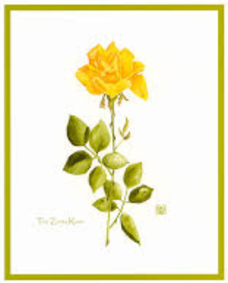
- Zonta International Convention - The 2014 Orlando Convention, taking place from June 27 – July 1, 2014, will offer a wonderful opportunity to meet outstanding women from around the globe. International Conventions are held every two years (even numbered years). Zontians from all over the world attend this important event. Biennial goals are defined and important resolutions are presented that define the direction of Zonta. Information on the conference is available on this web site: http://orlando2014.zonta.org
- Zonta District Conference – Zonta Area Conferences are held every two years (odd numbered years). At these events we elect district leadership and define district goals. We also elect upcoming district leadership and learn about activities of each club in the district. This is an excellent educational opportunity.
- Zonta District Governor’s Seminar – The Governor’s Seminar is held every two years (even numbered years) and focuses on educational opportunities.
- Zonta District 12 Area Meetings – Area meetings are held yearly. They allow interaction, education, and opportunities to network with other club members in your area.
- Club Meetings – Club meetings are usually held at least monthly. These meetings allow for networking, education and communication.

Zonta Club of ____________
PLEASE COMPLETE THE FOLLOWING INFORMATION WITH YOUR LOCAL CLUB INFORMATION AS APPLICABLE. DELETE INFORMATION THAT IS NOT NEEDED.
- About Us
  - Mailing Address
  - Phone
  - Web Site
- History
- Club chartered in __________
- 1/3 of Service Funds given to ZI projects
- Amelia Earhart Fund
- Violence Against Women
- Zonta International Service
- Club Number
- Leadership
  - President
  - Vice President
  - Secretary
  - Treasurer
  - Directors
  - Committees
- Meetings
- Service Projects
- Fundraisers
- Advocacy Work
- Financial Obligations
- Yearly Timelines
- By Laws
- Foundation (if applicable)
- Dues/Financial Commitment - Annual dues are $____, payable by May 1st (subject to change based on member’s vote). (You may be able to get your dues paid by your employer. It can’t hurt to ask.) Members are encouraged to donate annually to the Zonta International Foundation.

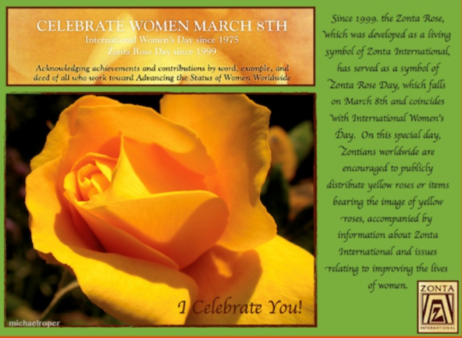
Zonta Calendar of Events
- Amelia Earhart Day- January 11th
- International Women’s Day – March 8th
- International Day of Peace – September 21
- United Nations Day – October 24
- International Day of Elimination of Violence Against Women and start of 16 Days of Activism Against Gender Violence – November 25th
- International Human Rights Day and end of 16 Day of Activism - December 10th

Upcoming Events in 2014
- International Women's Day/Rose Day - Mar 8
- Outreach Due Dates - Feb 1 and May 1
- Area Meetings
  - Area 1 Apr 25 and 26 - Black Hills
  - Area 2 Apr 11 and 12 - Laramie
  - Area 3 Mar 29 - Lakewood-Golden
  - Area 4 Apr 4 and 5 - Prowers County
- Transitional Board Meeting - June 6-8
- ZI Convention - June 27 - July 1, Orlando
- Governor's Seminar - Sept 20, Cheyenne

Zonta Additional Resources
- Zonta District 12: http://zontadistrict12.org
- Zonta International: http://zonta.org
- The Zontian magazine
- Zonta International monthly e-newsletter
- Zonta leadership (Governors, Lieutenant Governors, Area Directors, Club Presidents)
- Club Foundation Ambassadors
- Zonta International official social media on Facebook, Twitter, LinkedIn, YouTube and Flickr
- Zonta District Manual: http://www.zonta.org/LinkClick.aspx?fileticket=3hn1c26MDUo%3Dandtabid=75

Appendices
Clubs, use this section for any forms, documents, or other additions that you would like to add. If there are none, delete this section.

